Current Suggestions for Longlist of Scrutiny-Commissioned Reports for Consideration by Scrutiny 2024/25

Items ranked in priority order by Scrutiny Officer in line with TOPIC scoring criteria (see scoring below).
Current Suggestions for Scrutiny Committee 2024/25
Suggested Item | Pencilled in to Work Plan 2024/25?
- Anti-Social Behaviour | No
- Report back on arrangements from Leisure Contract Award | No
- Business Rates Non-Payment and Systems Management | No
- Adult Exploitation and Modern Slavery | Yes – March meeting
- Tourism | Scrutiny Officer liaising re: date
- OIEP Annual Reporting on Progress Against Pledges | No
- Money laundering/financial crime – inter-agency approach to addressing this in the city | No
- Beneficial ownership in the city | No
- Council-wide data and mapping | No

Regular/Standard Items | Pencilled in to Work Plan 2024/25?
Domestic Abuse Review Group Update | No
Child Poverty Review Group Update | No
Safeguarding Annual Report | Yes – September meeting
Citizen Experience Strategy – Annual Progress Report | Yes – July meeting (Cabinet report)
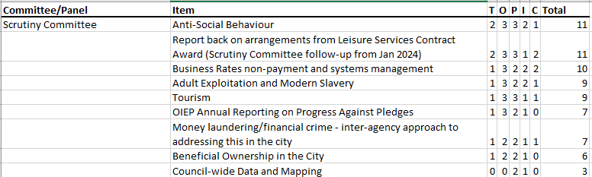
FOR INFORMATION: Current Panel suggestions 2024/25
Climate and Environment Panel:
Suggested Item | Pencilled in to Work Plan 2024/25?
- Waste/Waste Strategy | Yes – February meeting
- Local Area Energy Planning and Mitigation Measures Regarding Local Grid Constraints | Yes – September meeting
- Heat Network & Zoning | Yes – February meeting
- Oxford Climate Emergency Centre | No – not requested by Panel to date
- Biodiversity Net Gain – Biodiversity Units Feasibility Study (see officer decision here) | No – not requested by Panel to date
- Parks and Green Space Management Contracts with ODS (following outcome of Strategic Review of Services Provided by ODS) | No - not requested by Panel to date
- Energy Efficiency in Council commercial property portfolio, including potential for repurposing Council car parks | Panel asked Scrutiny Officer to liaise with officers following June meeting
- Loss and Damage to the Council as a result of climate change (e.g. costs incurred by the Council as a result of recent flooding) and how this could be addressed/funded | Panel asked Scrutiny Officer to liaise with officers following June meeting
- Fleet Decarbonisation | No – update will not be available until 2025 calendar year at the earliest
- Internal Council governance – including ensuring there is a clear client, clear responsibility and clear documentation setting out policy/process | No – officers advised this would be covered by other meetings (e.g. Audit & Governance Committee), so would not come to Panel as well as this would be duplication. Remove from list.
- Innovative longer-term partnership projects and funding initiatives that the Council could get involved in | No – not requested by Panel to date

Finance and Performance Panel:
Suggested Item | Pencilled in to Work Plan 2024/25?
- Comparative Analysis – Capital Programme Slippage | Yes – July meeting

Housing and Homelessness Panel:
Suggested Item | Pencilled in to Work Plan 2024/25?
- Alternative ‘innovative’ solutions to the housing crisis | Yes – July meeting (via Temporary Accommodation Cabinet report)
- Housing and Carbon Reduction | Yes – March meeting
- Landlord Services Transformation (Social Housing (Regulation) Act Compliance) | Yes – October meeting
- Implementation of Refugee Resettlement in Oxford | Yes – November meeting
- Implementation of Selective Licensing (Year 2) | No – no update available until June/July 2025

FOR INFORMATION: Panel Regular/Standing Items 2024/25:
Climate and Environment Panel:
Suggested Item | Pencilled in to Work Plan 2024/25?
Annual Air Quality Status Report | Yes – September meeting
Net Zero Masterplan | Yes – standing item at most meetings
Biodiversity strategy/action plan | Yes – February meeting

Finance and Performance Panel:
Suggested Item | Pencilled in to Work Plan 2024/25?
Scrutiny-commissioned performance monitoring | Yes – item at most meetings
Social Value/Impact in Procurement | Yes – April meeting
Issues faced by the Local Government Sector and how Oxford City Council compares | No – Panel not met yet in 2024/25 so has not agreed to request this item or not
Exempt Treasury Management Matters [discussion item] | Yes – standing item at meetings

Housing and Homelessness Panel:
Suggested Item | Pencilled in to Work Plan 2024/25?
Housing Performance Monitoring | Yes – July and November meetings
Building Safety & Compliance | No – tbc
Tenants’ Forum Update | No – tbc
Tenant Involvement and Empowerment Mini-Review Update | No – will be subsumed by forthcoming Tenant Involvement Strategy
Housing Complaint Handling Performance | Yes – October and November meetings
City of Sanctuary Accreditation | Yes – October meeting (Cabinet report)
Housing Ombudsman Complaint Handling Code Self-Assessment | Yes – March meeting
Tenant Satisfaction (STAR) Survey | Yes – March meeting

